USE-ATTAINABILITY ANALYSIS,
LOWER FRENCH GULCH AND THE BLUE RIVER DOWNSTREAM FROM FRENCH GULCH
NEAR BRECKENRIDGE, SUMMIT COUNTY, COLORADO

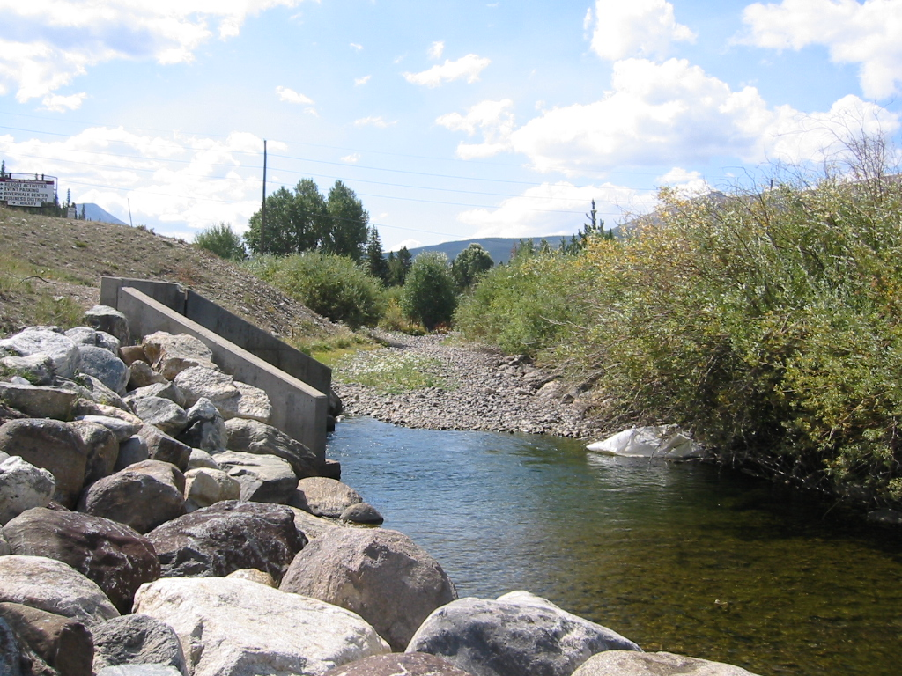

Prepared on Behalf of
Summit Water Quality Committee
U.S. Environmental Protection Agency
Colorado Department of Public Health & Environment

Prepared by

Mr. Lane Wyatt
Summit Water Quality Committee
P.O. Box 2308
Silverthorne, Colorado 80498

TDS Consulting Inc. Walsh Aquatic Consultants, Inc.

595 West Meadow Road 9560 Carr Street
Evergreen, CO 80439-9745 Westminster, CO 80021

With Assistance from
Nicole Vieira, Ph.D.
Colorado State University
Ft. Collins, CO 80525

May 5, 2003

Table of Contents

 |  | Page
 | Executive Summary | 1
1.0 | Introduction | 5
 | 1.1 Study-Area Description -------------------------------------------- | 5
 | 1.2 Objectives and Scope ----------------------------------------------- | 8
 | 1.3 Approach to Use-Attainability Analysis ------------------------- | 8
2.0 | Methods | 10
 | 2.1 Hydrologic Assessment -------------------------------------------- | 10
 | 2.2 Physical Habitat and Biological Assessment -------------------- | 11
 | 2.3 Chemical Assessment ---------------------------------------------- | 12
 | 2.4 Economic Evaluation ----------------------------------------------- | 13

3.0 Results ------------------------------------------------------------------------------------ 14
  - Hydrologic Assessment ------------------------------------------------------- 14
  - Physical Habitat and Biological Assessment ------------------------------- 18
    - General Overview ----------------------------------------------------- 18
    - Effects of Dissolved Zinc (D-Zn) on Brown Trout Populations - 19
    - Biological Criterion for Brown Trout ------------------------------ 21
    - Effects of Dissolved Zinc (D-Zn) on Macroinvertebrates ------- 24
    - Effects of Dissolved Cadmium (D-Cd) on Brown
Trout Populations ----------------------------------------------------- 25
    - Effects of Dissolved Cadmium (D-Cd) on Macroinvertebrates -- 29
    - Effects of Lead (D-Pb) Toxicity to Brown Trout ----------------- 29
    - Effects of Lead (D-Pb) Toxicity to Macroinvertebrates ---------- 30
    - Summary and Recommendations ----------------------------------- 30
3.3 Chemical Assessment ---------------------------------------------------------- 31
3.3.1 General Overview ----------------------------------------------------- 31
3.3.2 Seasonal and Year-to-Year Variations ------------------------------ 31
3.3.3 Streamflow and Water-Quality Time Trends ---------------------- 46
3.3.4 Average Water-Quality Characterization --------------------------- 47
    - Average and Seasonal (Low-Flow vs. High-Flow) HRD
Concentrations ---------------------------------------------------------- 51
3.3.6 TMs Standards Exceedances ----------------------------------------- 58
3.3.7 Blue River Point-of-Compliance (Superfund Remedial-Action
Targets) ----------------------------------------------------------------- 59
3.4 Economic Evaluation ---------------------------------------------------------- 59

4.0 Use Attainability ------------------------------------------------------------------------61
4.1 Existing Uses -------------------------------------------------------------------- 61
4.1.1 Hydrologic Assessment ---------------------------------------------- 61
4.1.2 Existing Physical Habitat and Biologic Conditions --------------- 61
4.1.2.1 Background to Bio-Monitoring Approach ----------------- 61
4.1.2.2 Benthic Macroinvertebrate Communities ---------------- 62
4.1.2.3 Trout Populations -------------------------------------------- 68
4.1.2.4 Existing Aquatic Habitat ------------------------------------ 70
4.1.3 Chemical Assessment ------------------------------------------------ 71
4.2 Future Uses --------------------------------------------------------------------- 74
4.2.1 Hydrologic Assessment ---------------------------------------------- 74
4.2.2 Physical Habitat and Biologic Assessment ------------------------ 74
4.2.3 Chemical Assessment ------------------------------------------------ 74

5.0 Conclusions and Recommendations ------------------------------------------------ 75
5.1 Stream Segmentation and Stream Standards -------------------------------- 75
5.2 Classifications and Designations --------------------------------------------- 76

6.0 Acknowledgments ---------------------------------------------------------------------- 76

7.0 References

Figures

Figure 1.1-1 – Map of UAA Study Area ---------------------------------------------------- 5
Figure 1.1-2 – Wellington Mine circa 1920 ---------------------------------------------------6
Figure 1.1-3 – Reiling Dredge in French Gulch at Lincoln City --------------------------- 7
Figure 3.1-1 – Interstation Streamflow Correlations ---------------------------------- 14-16
Figure 3.2-1a Habitat in French Creek below FG-8 --------------------------------------- 18
Figure 3.2-1b Habitat in French Creek below FG-5 --------------------------------------- 19
Figure 3.2-2 -- Relationship between D-Zn Concentrations and Mayfly Abundance at
Different Colorado Sites ----------------------------------------------------- 25
Figure 3.3-1 – Seasonal and Year-to-Year Monthly Streamflows --------------------31-33
Figure 3.3-2 – Trace-Metals (Concentrations) Time-Series -------------------------- 36-45
Figure 3.3-3 – Comparison of Annual Streamflows, 1995-2002 WYs ------------------ 46
Figure 4.1-1 - Mean abundance of main macroinvertebrate taxa at French Gulch
and Blue River Sites --------------------------------------------------------- 64
Figure 4.1-2 - Mean abundance of total individual and macroinvertebrate taxa
collected at French Gulch and Blue River sites ------------------------- 65
Figure 4.1-3 - Mean abundance of aquatic macroinvertebrates at the Farncomb
Hill site on French Gulch --------------------------------------------------- 66
Figure 4.1-4. Mean abundance of main macroinvertebrate taxa at French
Gulch and Blue River sites ------------------------------------------------ 68

Tables
Page
Table 2.1-1 – Summary of Streamflow Gaging-Station Records -------------------------- 10
Table 3.1-1 – Streamflow-Volume Comparisons ------------------------------------------- 17
Table 3.2-1 -- Comparison of 96-hr LC50 D-Zn concentrations from acute and
Chronic toxicity tests --------------------------------------------------------- 20
Table 3.2-2 -- Data used to develop the Biological Toxicity Criteria for Brown Trout in Colorado ------------------------------------------------------------------------ 22
Table 3.2-3 – Dissolved zinc hardness based criteria for acclimatized early life stages of brown trout ------------------------------------- 22
Table 3.2-4. Chronic brown trout criteria using the ELS equation for D-Zn --------------------------------------------------------------- 22

Table 3.2-5 -- Comparison of D-Zn Hardness Equation Criteria (ELS) with Table Value Standards for the Blue River Segment 2 ---------------- 23
Table 3.2-6 -- Reported literature values for brown trout D-Cd toxicity ------------ 26
Table 3.2-7. Trout data used to develop a hardness-based equation for chronic effects of D-Cd on acclimated adult brown trout -------------- 27
Table 3.2-8. Dissolved cadmium hardness based criteria for acclimated adult trout. Chronic regression based on data from Table 3.2-7. ------------ 27
Table 3.2-9. Chronic brown trout criteria based on our recommended trout equation for D-Cd. -----------------28
Table 3.2-10. Current TVS for D-Cd compared to future criteria for D-Cd ----- 29

Table 3.2-11. Reported literature values for D-Pb toxicity in brown trout ------- 29
Table 3.2-12-- Overall UAA Recommendations for D-Zn, D-Cd, and D-Pb ---- 30
Table 3.3-1 – French Gulch Data Summary for Selected Variables ---------------------- 48
Table 3.3-2 – Upper Blue River Data Summary for Selected Variables ----------------- 49
Table 3.3-3 – Blue River below French Gulch Data Summary for Selected Variables - 50
Table 3.3-4 – Blue River below Swan River Data Summary for Selected Variables --- 50
Table 3.3-5 – Summary of Monthly Streamflows --------------------------------------- 52-54
Table 3.3-6 – Comparisons of Average and 85th-Percentile Indicator Values ------------ 54
- Blue River upstream of French Gulch [Site BR-1] ---------------- 55
- French Gulch [Site FG-9/USGS 09046530] ------------------------ 55
- Blue River downstream of French Gulch (Point-of-Compliance, Site BR-2/BSD_BR0) ------------------------------------------------- 55
- Blue River upstream of Swan River [Site BR-3 (SEO Gage)] ---55
- Blue River downstream of Swan River
[Site BR-5/USGS 09046600] ----------------------------------------- 55
Table 4.1-1 - Average Streamflow and Seasonal Variations in Streamflow ------------- 61
Table 4.1-2 - Macroinvertebrate data summary for French Gulch and Blue River ----- 67
Table 4.1-3 - Summary trout data from French Gulch and Blue River fish surveys -–69
Table 4.1-4 - Physical habitat summary information for French Gulch, and Blue River 70
Table 4.1-5 - Rapid habitat assessment scores calculated for French Gulch and
Blue River -------------------------------------------------------------------- 70

Table 4.1-6 - Dissolved-Zinc Concentration and Load Characteristics ------------------ 72
Table 5.2-1 - Recommended Site-Specific Standards ------------------------------------- 75

Appendices

A. Selected Relevant Hydrologic and Water-Quality Data

A-1 Annual Streamflows by Gage, 1995-2002 WYs
A-2 Statistical Summary – Key Surface-Water/Water-Quality Sites
A-3 Statistical Summary – Selected Groundwater-Monitoring Wells, lower
French Gulch Area
A-4 Water-Quality versus Flow Relationships
A-5 Sample-Date Streamflow Relationships
A-6 Interstation Flow Correlations
A-7 Streamflow Trends
A-8 CDPHE-WQCD Trace-Metals Stream Standards
- French Gulch (Blue River Segment 11)
b. Blue River (Blue River Segment 2)

B. Literature Review: Toxicity Effects of Zinc, Cadmium and Lead on Aquatic
Biology in the Blue River Watershed

C. Post-ROD Monitoring Program

C.1 General Overview
C.2 Water-Quality Component
C.3 Aquatic-Habitat Component

USE-ATTAINABILITY ANALYSIS,
LOWER FRENCH GULCH AND THE BLUE RIVER
DOWNSTREAM FROM FRENCH GULCH
NEAR BRECKENRIDGE, SUMMIT COUNTY, COLORADO

Executive Summary

The Blue River Use-Attainability Assessment (UAA) was initiated to facilitate the anticipated institutional and regulatory linkages between CERCLA remediation work planned for the Wellington-Oro Mine (French Gulch) and Clean Water Act (CWA) targets for downstream (Blue River) water quality, as quantified through the 303(d) listing and TMDL assessment process. This UAA uses available data, information, and an extensive review of the scientific literature and research studies to develop recommendations for site-specific stream standards. Standards are being recommended for cadmium, lead and zinc concentrations in Blue River, Segments 2 and 11 (the Blue River from French Creek to the Swan River and the lower stream reach of French Creek, respectively). A change in the definition of Segment 2 and a change in designation for Segment 2 are also proposed in this UAA.

Aquatic life in these segments is currently severely impacted by a combination of toxic concentrations of metals and a significant lack of suitable aquatic habitat. Under pending CERCLA agreements, the primary source of metals loads (the Wellington-Oro Mine) will be treated with a design target of 225 μg/L of dissolved zinc (D-Zn) and 4.0 μg/L of dissolved cadmium (D-Cd). The point of compliance will be site BR-2, in the Blue River, which is 115 feet (ft) downstream from the confluence with the French Creek. Aquatic habitat in French Creek will not be improved in the foreseeable future and will continue to be a primary limiting factor for aquatic life in Segment 11. It is intended that a brown trout fishery including sustaining aquatic macroinvertebrates and supporting terrestrial ecosystem will be supported in Segment 2, subject to existing and anticipated future limitations in streamflow and physical habitat.

A practical approach was used in developing the recommendations in this UAA:

- Current conditions in terms of aquatic life, physical habitat, stream hydrology and water column chemistry were evaluated based on existing data and field studies;

- Extensive literature reviews (see Appendix B) and professional judgment were used to determine the aquatic life potential for the stream segments in the study area, recognizing projected (a) future water quality conditions (after implementation of the Wellington-Oro Mine treatment facility) and (b) existing physical, biologic or hydrologic limitations to aquatic life;

- Site-specific water quality standards were developed that, although are not fully protective, are representative of the limited aquatic life potential due to physical habitat limitations.

This UAA determined that physical limitations in French Creek (Blue River Segment 11), primarily due to historic dredge mining, will limit aquatic life even if water quality attained State table value standards (TVS). Upstream from the Wellington-Oro Mine a viable Colorado River Cutthroat population exists. Improvements in water quality and habitat, if possible, would potentially threaten these native fish with the introduction of non-native fish species migrating from the Blue River. It was determined that the value of protecting the native fish far exceeded the benefit of attempting to restore aquatic life in Segment 11.

Although there have been considerable local expenditures to restore Blue River Segment 2 it is still severely impacted by historic dredge mining. As a result, the upstream two thirds of this segment will not support a diverse aquatic ecosystem, however a limited brown trout fishery is a reasonable goal. Upstream of the confluence with French Creek, historic mining and urbanization limit the trout population and thus the possibilities of recruitment by fish moving downstream into Segment 2. Further downstream, Segment 2 is blocked by dredge spoil from its connection to Dillon Reservoir, thus limiting the opportunity for fish to migrate upstream into Segment 2. In addition, the stream channel in Segment 2 provides very little suitable aquatic habitat for either brown trout or macroinvertebrates.

In spite of these physical constraints and existing water quality, some trout do reside in Segment 2. These fish are not reproducing in this segment and are highly acclimated to trace metals concentrations. Site-specific conditions, therefore, are severely limited for trout species, especially trout fry and juveniles. Despite over a decade of community and regulatory agency efforts to identify remediation strategies, future water quality in French Creek and Blue River Segment 2 just below the confluence with French Creek will be limited by the technological capability of the Wellington-Oro Mine treatment facility.

It should also be noted that hydrologic conditions result in seasonally fluctuating hardness levels and trace metals concentrations and thus changing toxicity conditions for aquatic life. Recognizing this situation, regression analysis was conducted on available brown trout and other trout data to evaluate the relationship between D-Zn and D-Cd toxicity to water hardness conditions. This analysis relied heavily on recent studies and input from the Colorado Division of Wildlife. In addition, data the EPA Ambient Water Quality Criteria documents were also review. The UAA evaluated both acute and chronic toxicity from D-Zn, D-Cd, and D-Pb to brown trout. From these analyses site-specific hardness based equations were developed which should be protective of trace metal acclimated adult brown trout. Because of limited data on D-Cd acute toxicity to brown trout and a lack of suitable data from other trout studies, the UAA does not propose a site-specific acute standard for D-Cd. It must be stated that these proposed equations are not fully protective of a diverse aquatic life system, but rather were developed for the unique circumstances that limit potential species diversity in Blue River Segment 2.

Finally, metals toxicity to benthic macroinvertebrates was evaluated to ensure that a food source would be available to brown trout at D-Zn and D-Cd concentrations proposed in this UAA. In general, macroinvertebrates are more tolerant than fish of these metals. Metals concentrations proposed in the UAA, may not be tolerated by the most sensitive macroinvertebrate species, but many more tolerant species are likely to be present in the Blue River.

To achieve the goal of protecting a brown trout fishery and recognizing the physically limitations in these stream segments, this UAA recommends the following site-specific stream standards:

 | D-Cd chronic, μg/L
Segment 2, Blue River | Brown Trout (chronic) = e ^{(1.028(ln(hard)-3.33).}
Segment 11, French Gulch | Ambient Quality

 | D-Zn (acute & chronic), μg/L
Segment 2, Blue River | Brown Trout (acute and chronic) = e ^{(1.25(ln(hard)+0.799).}
Segment 11, French Gulch | Ambient Quality

 | D-Pb, μg/L
Segment 2, Blue River | Table Value Standards
Segment 11, French Gulch | Ambient Quality

Blue River Segment 2 should be extended to the confluence with the Swan River – this segment is a more logical unit reaching from French Creek to the Swan River, instead of stopping one mile above the confluence with the Swan River, as it currently does. Currently, the description of Blue River Segment 2 is “the mainstem of the Blue River from the confluence with French Gulch to a point one mile above the confluence with Swan River.” The UAA recommends extending this segment to the confluence with the Swan River. This will bring a significant amount of flow and water quality data into the segment by incorporating sampling site BR-3. This will help with future analysis of this stream segment for such things as 303(d) listing. Further, this is a more logical segmentation of the Blue River.

Over the next decade the Wellington Oro Mine remedial treatment facility will go on-line and significant habitat improvements take place in the lower reaches of Segment 2. When these activities are complete a more detailed assessment of Segment 2 would be advised.

In addition, Segment 2 is currently designated as a “reviewable” water indicating that Colorado’s Antidegradation Review applies. Antidegradation is applied to protect existing water quality where it is “better than necessary to support aquatic life class 1 … uses” (See 31.8(2)(b)(ii) in Colorado’s Basic Standards and Methodologies (5 CCR 1002-31)). Because water quality and physical habitat in this segment will be limiting and the segment is unable to support a diversity aquatic life, the designation should be changed to Use Protected.

1.0 Introduction

1.1 Study-Area Description

The geographic areal extent of this Use Attainability Analysis (UAA) includes French Gulch from above the Wellington-Oro Mine site (Blue River Segment 11) and the Blue River from just above the confluence with French Gulch downstream almost to Dillon Reservoir (Blue River Segment 2 and the lower part of Segment 1) (Figure 1.1-1).

Figure 1.1-1 – Map of UAA Study Area
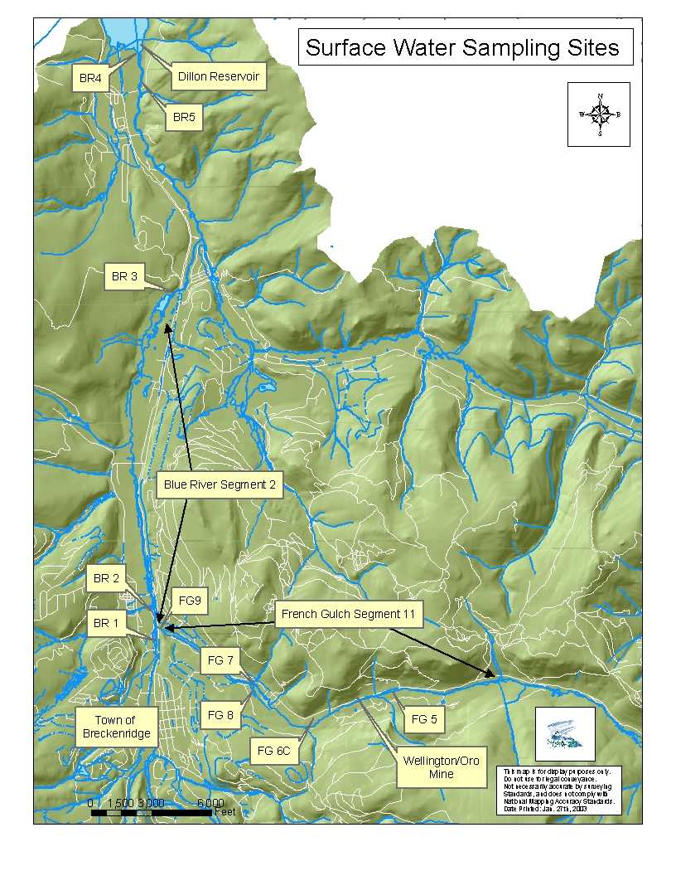

The aquatic habitat of this segment of French Gulch was entirely obliterated by historical dredge-mining operations. These floating placer-mining facilities turned the stream-channel bed and associated riparian community upside down in the search for gold, leaving a trench of cobbles where there was once a stream channel (Figure 1.1-2). In many cases, the stream currently disappears as it flows though these piles of rock cobbles. Upstream from the Wellington-Oro Mine site, water quality and habitat in French Gulch support a healthy population of Colorado River cutthroat.

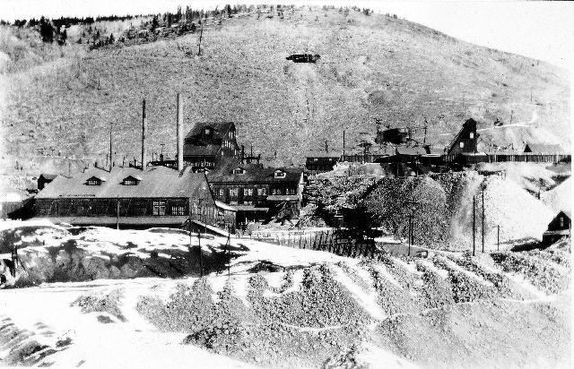

Figure 1.1-2 Wellington Mine circa 1920

The Wellington-Oro mining complex was a lode mine and mill operation producing zinc, lead gold, and silver. The Wellington Mine began operation in 1887, and it was connected underground to the Oro Mine in 1903. It was the largest producing mine in the Breckenridge area reaping over $33 million and employing as many as 150 people before permanently closing in 1972. The mine extends 400 feet (ft) above the top floor of the mill and 800 ft below. There are over 12 miles (mi) of underground works. Placer mining techniques, especially floating placer dredges in the streambeds, were also used in French Gulch and the Blue River from the mid 1800s until the 1940s (Figure 1.1-3). Placer-mining activities removed alluvial valley materials, leaving behind piles of boulders, cobbles and gravel principally along stream channels.

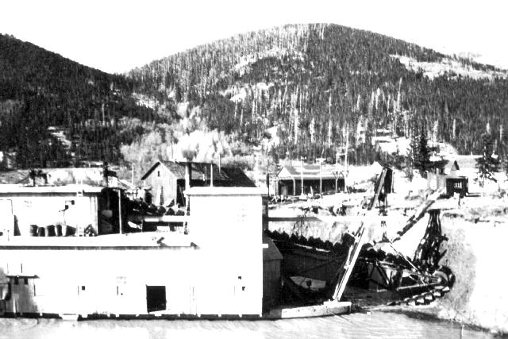

Figure 1.1-3 Reiling Dredge in French Gulch at Lincoln City ~ 1920

French Gulch and the Blue River still receive trace-metals loadings in both groundwater and surface waters (principally streams) from mill tailings, buried roaster fines, and mine waste rock near the Wellington-Oro Mine site (Morrissey, 1995). Further, the aquatic habitat of lower French Gulch was entirely eliminated and flows were rerouted by historic dredge mining operations. Trout populations have been eliminated and aquatic benthic communities have been reduced in French Gulch downstream of the Wellington-Oro Mine site, due to high concentrations of trace metals (primarily zinc and cadmium) originating from this site, and also from the elimination of aquatic habitat (USEPA, 2002). Similarly, reduced trout numbers in the Blue River, below the confluence with French Gulch, is likely associated with metal toxicity and poor aquatic-habitat conditions.

Upstream from the Wellington-Oro Mine site, water quality conditions and undisturbed habitat support a healthy population of Colorado River cutthroat, as well as benthic invertebrates (USGS, 2002). Thus, the Colorado Division of Wildlife (CDOW) is concerned that “clean up” -- that is, improvement of water quality and improved aquatic habitat in French Gulch -- would result in the migration of nonnative fish species into the cutthroat habitat in French Gulch, thereby reducing their viability.

Future water quality in this segment will be technology-based and is primarily dependent upon the CERCLA remediation (URS, 2002b). For the reasons above, both the CERCLA remediation of the Wellington-Oro Mine site and this UAA will limit improvements in French Gulch to substantial improvements in water quality from the Mine water treatment facility. Currently, there is no plan or financial means to restore the aquatic habitat of French Gulch to pre-mining conditions. Stream segments along the Blue River, on the other hand, will be evaluated to determine their full aquatic-life potential, including both water-quality and aquatic-habitat considerations. These stream segments of the Blue River also consist of an human and mining impacted unnatural stream channel containing placer dredge cobbles, a mortared-in-place kayak course, manmade stream-hydraulic features, a wastewater treatment plant discharge, and a substantial interaction (gains/losses) with the alluvial groundwater system.

1.2 Objectives and Scope

In general, this UAA document evaluates the current physical, chemical and biological conditions of Blue River segments 2, 11, and parts of segment 1 (see Figure 1.1-1). Also, it projects water chemistry conditions after the implementation of the proposed Wellington-Oro Mine remedial treatment facility, which is scheduled to be built in the year 2005 under CERCLA authorization (USEPA, 2002). The UAA examines the aquatic life potential for these stream segments and compares projected stream conditions after the treatment facility is operating with aquatic life needs. This information will be used to propose site-specific changes to water-quality standards.

This UAA is intended to assist the regulatory agencies: principally the U.S. Environmental Protection Agency (USEPA) and Colorado Department of Public Health and Environment (CDPHE). This assessment is to facilitate the anticipated institutional and regulatory linkages between CERCLA remediation work planned for the Wellington-Oro Mine (French Gulch) and Clean Water Act (CWA) targets for downstream (Blue River) water quality, as quantified through the 303(d) listing and TMDL assessment process. This assessment relies primarily on existing data, information, and studies. The primary project goal is to develop a UAA document that provides technically sound recommendations for site-specific classifications and standards for use in upcoming water-quality rulemaking hearings by the CDPHE’s Water Quality Control Commission (WQCC), scheduled for July 2003.

1.3 Approach to Use-Attainability Analysis

The goal of this UAA is to develop technically justifiable site-specific water quality standards for the stream segments under consideration. The State of Colorado recognizes a UAA as one of the appropriate methods to support site-specific standards (5 CCR. Section 1002-31, Sect 31.7(1)(b)(iii)). The approach used in developing this UAA is consistent with the State’s definition of a UAA (Section 31.5(30)): “an assessment of the factors affecting the attainment of aquatic life uses or other beneficial uses, which may include physical, chemical, biological and economic factors.”

The approach used in developing this UAA can be summarized as follows:
- Characterize existing conditions in terms of aquatic life, physical habitat, stream hydrology and water column chemistry;
- Attempt to project future water quality conditions that are expected to exist after the implementation of the CERCLA water treatment plant at the Wellington-Oro Mine site;
- Use literature information and professional judgment to determine the aquatic life potential for the stream segments in the study area recognizing future water quality conditions and any existing physical, biologic or hydrologic limitations to aquatic life;
- Propose site-specific water quality standards that are protective of potential aquatic life.

This UAA provides a detailed characterization of water quality and a comparison to relevant water quality standards for several monitoring locations, where data are available for the study area. Information from this description of chemical and hydrologic conditions is used to depict future stream chemistry based on anticipated metals removal capabilities of the CERCLA remedial project (USEPA, 2002).

The UAA uses available data and information to characterize the existing aquatic communities (both trout populations and macroinvertebrate communities) and physical habitat conditions in both French Gulch and the Blue River, including seasonal streamflows, aquatic habitat, and channel benthic substrates. A detailed literature review on the effects of dissolved species of zinc, lead, and cadmium (D-Zn, D-Pb, and D-Cd, respectively) on aquatic biota, including trout and macroinvertebrates, is performed to assess the aquatic life potential of the stream segments under consideration. Information on existing habitat and literature information on aquatic community potential are used to determine the potential aquatic communities that can be expected to exist if water-quality conditions improve as a result of the Wellington-Oro Mine remedial treatment facility. Conclusions from this analysis then are used to propose site-specific water-quality standards for the stream segments under consideration by this UAA.

