USE-ATTAINABILITY ANALYSIS,
LOWER FRENCH GULCH AND THE BLUE RIVER DOWNSTREAM FROM FRENCH GULCH
NEAR BRECKENRIDGE, SUMMIT COUNTY, COLORADO

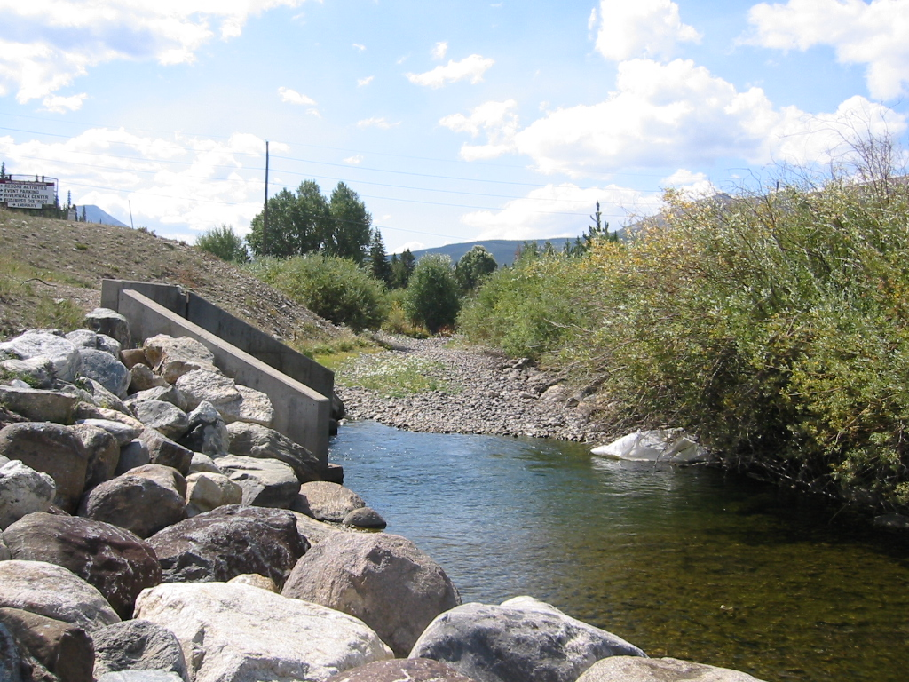

Prepared on Behalf of
Summit Water Quality Committee
U.S. Environmental Protection Agency
Colorado Department of Public Health & Environment

Prepared by

Mr. Lane Wyatt
Summit Water Quality Committee
P.O. Box 2308
Silverthorne, Colorado 80498

TDS Consulting Inc. Walsh Aquatic Consultants, Inc.

595 West Meadow Road 9560 Carr Street
Evergreen, CO 80439-9745 Westminster, CO 80021

With Assistance from
Nicole Vieira, Ph.D.
Colorado State University
Ft. Collins, CO 80525

May 5, 2003

USE-ATTAINABILITY ANALYSIS,
LOWER FRENCH GULCH AND THE BLUE RIVER
DOWNSTREAM FROM FRENCH GULCH
NEAR BRECKENRIDGE, SUMMIT COUNTY, COLORADO

Executive Summary

The Blue River Use-Attainability Assessment (UAA) was initiated to facilitate the anticipated institutional and regulatory linkages between CERCLA remediation work planned for the Wellington-Oro Mine (French Gulch) and Clean Water Act (CWA) targets for downstream (Blue River) water quality, as quantified through the 303(d) listing and TMDL assessment process. This UAA uses available data, information, and an extensive review of the scientific literature and research studies to develop recommendations for site-specific stream standards. Standards are being recommended for cadmium, lead and zinc concentrations in Blue River, Segments 2 and 11 (the Blue River from French Creek to the Swan River and the lower stream reach of French Creek, respectively). A change in the definition of Segment 2 and a change in designation for Segment 2 are also proposed in this UAA.

Aquatic life in these segments is currently severely impacted by a combination of toxic concentrations of metals and a significant lack of suitable aquatic habitat. Under pending CERCLA agreements, the primary source of metals loads (the Wellington-Oro Mine) will be treated with a design target of 225 μg/L of dissolved zinc (D-Zn) and 4.0 μg/L of dissolved cadmium (D-Cd). The point of compliance will be site BR-2, in the Blue River, which is 115 feet (ft) downstream from the confluence with the French Creek. Aquatic habitat in French Creek will not be improved in the foreseeable future and will continue to be a primary limiting factor for aquatic life in Segment 11. It is intended that a brown trout fishery including sustaining aquatic macroinvertebrates and supporting terrestrial ecosystem will be supported in Segment 2, subject to existing and anticipated future limitations in streamflow and physical habitat.

A practical approach was used in developing the recommendations in this UAA:

- Current conditions in terms of aquatic life, physical habitat, stream hydrology and water column chemistry were evaluated based on existing data and field studies;

- Extensive literature reviews (see Appendix B) and professional judgment were used to determine the aquatic life potential for the stream segments in the study area, recognizing projected (a) future water quality conditions (after implementation of the Wellington-Oro Mine treatment facility) and (b) existing physical, biologic or hydrologic limitations to aquatic life;

- Site-specific water quality standards were developed that, although are not fully protective, are representative of the limited aquatic life potential due to physical habitat limitations.

This UAA determined that physical limitations in French Creek (Blue River Segment 11), primarily due to historic dredge mining, will limit aquatic life even if water quality attained State table value standards (TVS). Upstream from the Wellington-Oro Mine a viable Colorado River Cutthroat population exists. Improvements in water quality and habitat, if possible, would potentially threaten these native fish with the introduction of non-native fish species migrating from the Blue River. It was determined that the value of protecting the native fish far exceeded the benefit of attempting to restore aquatic life in Segment 11.

Although there have been considerable local expenditures to restore Blue River Segment 2 it is still severely impacted by historic dredge mining. As a result, the upstream two thirds of this segment will not support a diverse aquatic ecosystem, however a limited brown trout fishery is a reasonable goal. Upstream of the confluence with French Creek, historic mining and urbanization limit the trout population and thus the possibilities of recruitment by fish moving downstream into Segment 2. Further downstream, Segment 2 is blocked by dredge spoil from its connection to Dillon Reservoir, thus limiting the opportunity for fish to migrate upstream into Segment 2. In addition, the stream channel in Segment 2 provides very little suitable aquatic habitat for either brown trout or macroinvertebrates.

In spite of these physical constraints and existing water quality, some trout do reside in Segment 2. These fish are not reproducing in this segment and are highly acclimated to trace metals concentrations. Site-specific conditions, therefore, are severely limited for trout species, especially trout fry and juveniles. Despite over a decade of community and regulatory agency efforts to identify remediation strategies, future water quality in French Creek and Blue River Segment 2 just below the confluence with French Creek will be limited by the technological capability of the Wellington-Oro Mine treatment facility.

It should also be noted that hydrologic conditions result in seasonally fluctuating hardness levels and trace metals concentrations and thus changing toxicity conditions for aquatic life. Recognizing this situation, regression analysis was conducted on available brown trout and other trout data to evaluate the relationship between D-Zn and D-Cd toxicity to water hardness conditions. This analysis relied heavily on recent studies and input from the Colorado Division of Wildlife. In addition, data the EPA Ambient Water Quality Criteria documents were also review. The UAA evaluated both acute and chronic toxicity from D-Zn, D-Cd, and D-Pb to brown trout. From these analyses site-specific hardness based equations were developed which should be protective of trace metal acclimated adult brown trout. Because of limited data on D-Cd acute toxicity to brown trout and a lack of suitable data from other trout studies, the UAA does not propose a site-specific acute standard for D-Cd. It must be stated that these proposed equations are not fully protective of a diverse aquatic life system, but rather were developed for the unique circumstances that limit potential species diversity in Blue River Segment 2.

Finally, metals toxicity to benthic macroinvertebrates was evaluated to ensure that a food source would be available to brown trout at D-Zn and D-Cd concentrations proposed in this UAA. In general, macroinvertebrates are more tolerant than fish of these metals. Metals concentrations proposed in the UAA, may not be tolerated by the most sensitive macroinvertebrate species, but many more tolerant species are likely to be present in the Blue River.

To achieve the goal of protecting a brown trout fishery and recognizing the physically limitations in these stream segments, this UAA recommends the following site-specific stream standards:

 | D-Cd chronic, μg/L
Segment 2, Blue River | Brown Trout (chronic) = e ^{(1.028(ln(hard)-3.33).}
Segment 11, French Gulch | Ambient Quality

 | D-Zn (acute & chronic), μg/L
Segment 2, Blue River | Brown Trout (acute and chronic) = e ^{(1.25(ln(hard)+0.799).}
Segment 11, French Gulch | Ambient Quality

 | D-Pb, μg/L
Segment 2, Blue River | Table Value Standards
Segment 11, French Gulch | Ambient Quality

Blue River Segment 2 should be extended to the confluence with the Swan River – this segment is a more logical unit reaching from French Creek to the Swan River, instead of stopping one mile above the confluence with the Swan River, as it currently does. Currently, the description of Blue River Segment 2 is “the mainstem of the Blue River from the confluence with French Gulch to a point one mile above the confluence with Swan River.” The UAA recommends extending this segment to the confluence with the Swan River. This will bring a significant amount of flow and water quality data into the segment by incorporating sampling site BR-3. This will help with future analysis of this stream segment for such things as 303(d) listing. Further, this is a more logical segmentation of the Blue River.

Over the next decade the Wellington Oro Mine remedial treatment facility will go on-line and significant habitat improvements take place in the lower reaches of Segment 2. When these activities are complete a more detailed assessment of Segment 2 would be advised.

In addition, Segment 2 is currently designated as a “reviewable” water indicating that Colorado’s Antidegradation Review applies. Antidegradation is applied to protect existing water quality where it is “better than necessary to support aquatic life class 1 … uses” (See 31.8(2)(b)(ii) in Colorado’s Basic Standards and Methodologies (5 CCR 1002-31)). Because water quality and physical habitat in this segment will be limiting and the segment is unable to support a diversity aquatic life, the designation should be changed to Use Protected.

